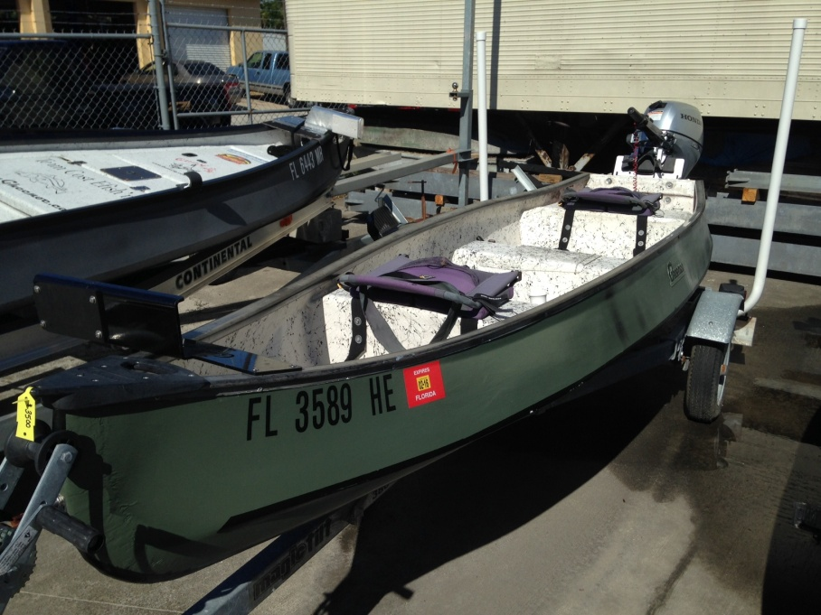

**1992 13’ Gheenoe**

Offered At: $3,500.00

Contact Us At: CustomGheenoe@cfl.rr.com

Equipped:

Front Bench

Center Bench

Rear Bench

Troling Motor Mount

Manual Jack Plate

2012 Honda 9.9 4 stroke

Trailer with guide ons